New Printing of 24¢ Common Buckeye coil stamp

In February of 2007, while the PNC³ ‘2006 New Issue Pages’ were being formatted for the catalog, it came to our attention that there was a ‘new’ printing on the 24¢ Buckeye coil of 100.

Both Donna Rajotte and Renate Fearonce in Tucson announced that they had the 24¢ Buckeye coil in a shrink wrapped package, and both noted that the lettering on the stamps appeared to be darker than the original stamps. Donna recently confirmed that the shrink wrapped stamps she has are from a carton dated November, 2006, which incidentally coincides with the 11/06 reprinting of the Buckeye self-adhesive pane of 20 listed in the USA Philatelic catalog.

The 24¢ Common Buckeye coil of 100 was issued in Washington, DC on March 8, 2006 in a plastic bubble pack.

In July of 2006, Thomas E Harley, Sr. sent me examples of a ‘different’ printing of the 24¢ Buckeye that he had purchased at the Saltsburg, PA post office and asked for an opinion. My reply to him at that time was that I thought the stamps were over-inked as far as the black ink and I dismissed them as just an inking variety. I returned them to Tom in the envelope provided, which was cancelled in Cincinnati, Ohio on July 24, 2006.

The announcement of the ‘new’ find prompted numerous emails and postings on the Virtual Stamp Club web site, the US Stamps Group on Yahoo and our own PNC³ discussion board.

An email from John Himes provided the following information: In examining the old vs. the new ... I was taken by the comment by Bob Novak that the left wing area is more pinkish on the older version than the new. That seemed to be true. So I kept studying the stamp, and I think I found an even more stunning difference.
On the older, original printing, the shadow under the butterfly has many small red printing dots, giving the shadow a pinkish cast. On the newer printing, the shadow seems to have very few, if any, of the reddish dots, making the shadow appear a much darker gray, with no pinkish cast whatsoever. After studying the two stamps side by side for quite a while, that was the most glaring difference I saw, and I believe it would allow me to distinguish them every time.

In the meantime, I had requested that Tom Harley return the stamps to me for further examination. Tom not only returned the stamps, but also included the postmarked envelope and our original correspondence. Tom also confirmed that the Saltsburg purchase was in a bubble pack.

After re-examining the ‘new’ stamps from Tom, I concluded that they matched those described by Bob Novak and John Himes and that the stamps found in July of 2006 were a second printing.

Frank Covey, chairman of the PNC³ catalog committee, asked me to re-examine the July 2006 stamps under 30 power magnification to see if they had red dots in the shadow under the left wing. If so, they are more like the original printing. If not, the July printing was new. After careful examination, I replied to Frank that I did not see any red dots in the July 2006 printing.

Frank then concluded: “Then I think it is safe to say that the July printing was the new printing even though most of us did not pick up on it until February 2007. The July 2006 printing and the February 2007 printing appear to be identical. My feeling is that the July 2006 variety was a new printing, even though it was packaged in a bubble wrap and the February 2007 find ‘may’ be a third printing, although other than the different shrink wrap package, the stamps appear to be the same.”

I think that there might be a third printing. I posted a side-by-side comparison scan of all three on the Virtual Stamp Club site and sent emails to all the catalog committee members. The original printing in March of last year has tiny red dots creating a pinkish hue to the shadow under the left wing and in the white area near the top of the same wing. On the second printing, discovered in July, all of the lettering is darker and the shadow is devoid of any red dots, resulting in a darker, denser shadow.

What I believe is a third printing can be found in the shrink wrap packaging, which although not noticed until last month, has been around since last November. The only difference that I have noted so far is in the shadow under the left wing. On the ‘third’ printing, the shadow has numerous areas of lighter color giving the appearance of splotches. This is evident in the side-by-side scan, which unfortunately will not reproduce well here.

It might be worth your while to look for examples of the second printing in bubble packs and check your correspondence for early uses of the second printing.

This whole situation with a second and possibly a third printing might well be nit-picking and drawing a real fine line, but it underscores what a big help it would be for specialists if the U. S. Postal Service would go back to the practice of changing plate numbers when there is a reprint involving design changes, especially like those with the visual differences between the first and second printings of the Common Buckeye.

On the right in the picture below is a scan of the original stamp. In the center is the stamp discovered in July 2006, and on the left is the stamp from the February 2007 find.

Ron Maifeld

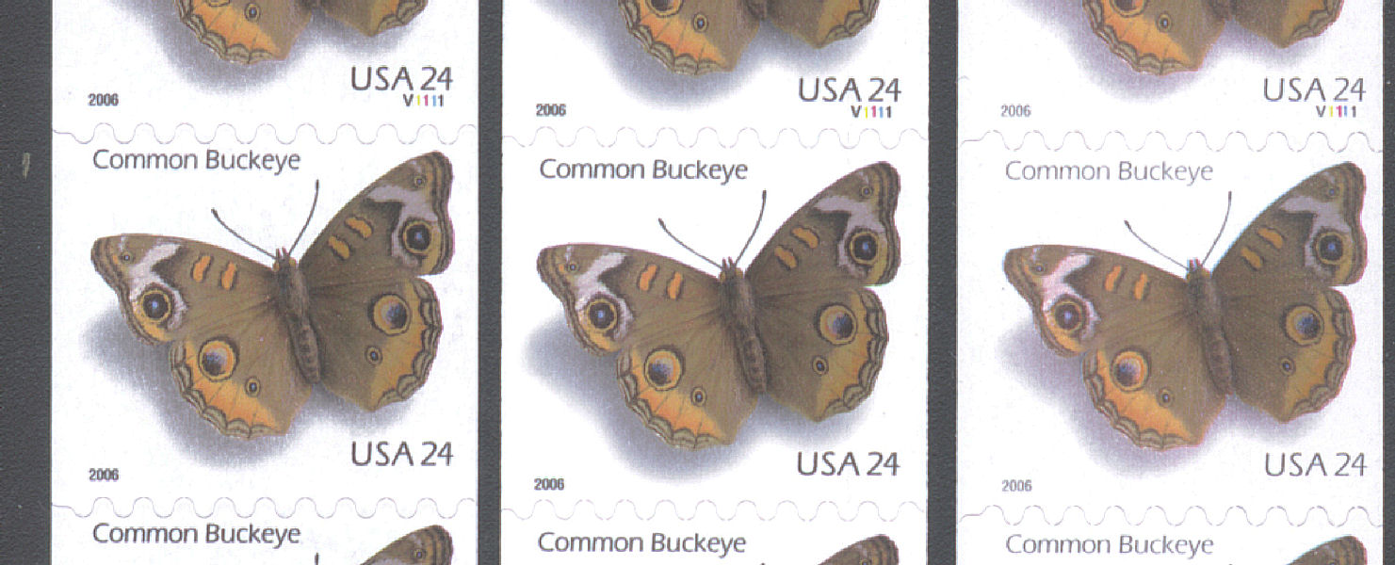
F

