Seacoast Varieties of PNC ID 2003-5.22

(5c) NDN Seacoast (SA) (AP)
Serpentine die cut vertically
By Frank Covey
The Black Ghost
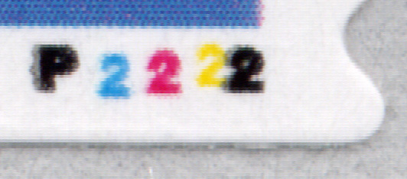
To the left is a newly discovered variety of the (5c) Nonprofit SA Seacoast from Ashton-Potter with Serpentine die cuts on two sides (vertical sides). The variety is called the “Black Ghost”.

In the plate number P2222, the letter “P” and the last “2” are black characters. Each black character has a shadow of itself just to the left of the darker printed character. It’s not known what caused this. P2222 is the only plate number so far for PNC ID 2003-5.22. The “Black Ghost” has only been observed on rolls with top back numbers.
P2222 Black Ghost

Yellow Shift Black Ghost
On this “Black Ghost” variety, the yellow printing cylinder is shifted far enough to the right that the yellow “2” is printed underneath the black “2”. The shift also causes a light yellow line on the top right hand portion of the stamp. Because the yellow printing cylinder is slightly below the black printing cylinder, a small portion of the yellow “2” shows beneath the black “2”.
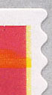

This page was written and scheduled to be included in the January 2005 issue of Coil Line. Because the club publication is in black and white and the varieties will not reproduce well in that format, the page may not be used.
(REM)

