Components of the LIC (Label Identification Code)

The label characteristics provided in the LIC and the order in which they appear are as follows.

1. The LD (Label Date), if any, that is printed on the label, e.g., LD-2006
2. The letter that identifies the Label Type followed by the appropriate Label Type measurements in mm, e.g., S 49/20 (Split type label with DT=49mm and C=20mm) [See I & II below]. The letter “J” precedes the Label Type letter for BEP “Jumbo” labels (See V, Label Sizes below).
3. The Print Color given in commonly understood terms. Where greater color discrimination is required, Stanley Gibbons color designations are used.
4. For certain 3000-roll labels a capital letter may follow to designate the font style used for the “3” in “3000”. (C for Celtic, B for Blunt, P for Point) [See IV below].
5. The label stock description or paper type (Lp), followed by its fluorescence in parenthesis. For paper labels where the specific label stock type is unspecified or uncertain, a question mark appears (?). The degree of Fluorescence under LWUV is designated as follows, D for “dead” or none, LB for Low Bright, MB for Medium Bright and HB for High Bright [See III below].
6. Other label characteristics that were noted and may be of significance in specifying the label, e.g., the size, color and position of over-print data.

An example of a LIC and its components:

For label with ID # 1895-BA2
The measured lengths of “U” to “E” and the “©” text line” (UE/C) – 21mm and 13mm respectively

The Label Type A - the Arch Label Type

The print color - Blue
The year date printed on the label - 1981

LD-1981 A 21/13 Blue
Lp 2(D)

The reactivity of the label Stock to LWUV light - ”Dead” or none
The type of label stock -Type 2 paper

I - Label Types

Blank Label – Type N

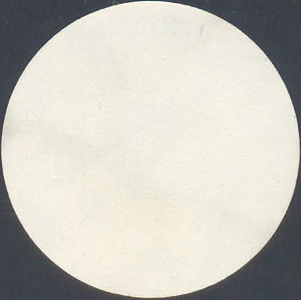
Label is devoid of print.

Emblem Label – Type E
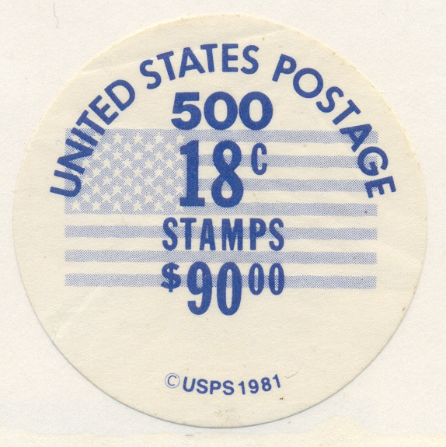
Some portion of the design subject that appears on the actual stamp is printed on the label.

Arch Label – Type A
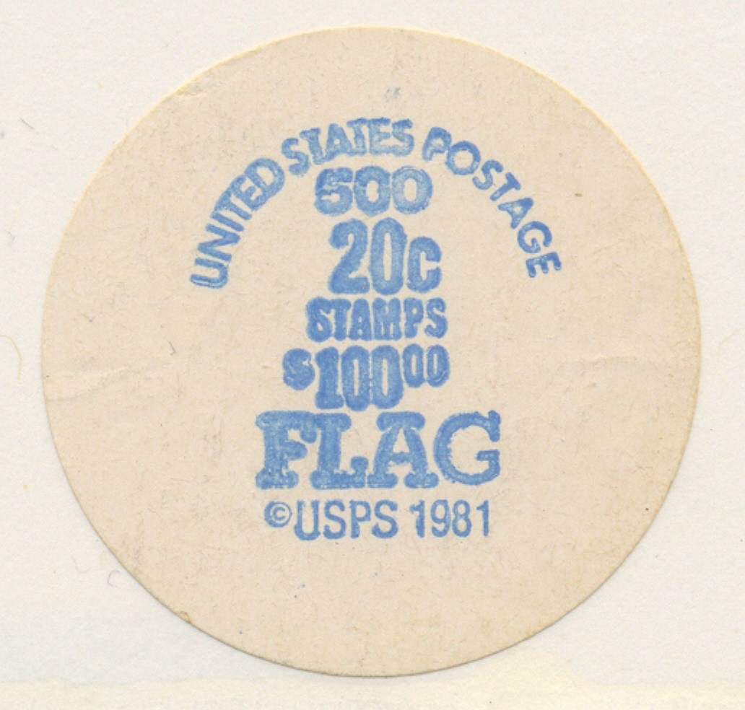
“UNITED STATES POSTAGE” appears as a continuous arch across the top of the label.

Split Label – Type S
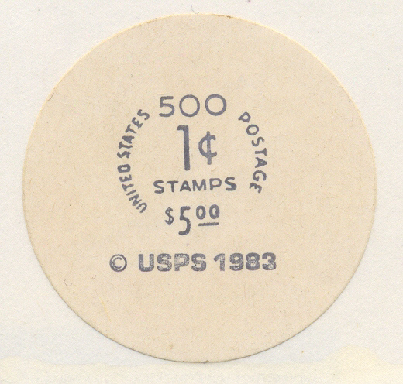
The arch of “UNITED STATES POSTAGE” is ‘split’ into two unequal segments by the roll size number.

Item Line Label – Type I
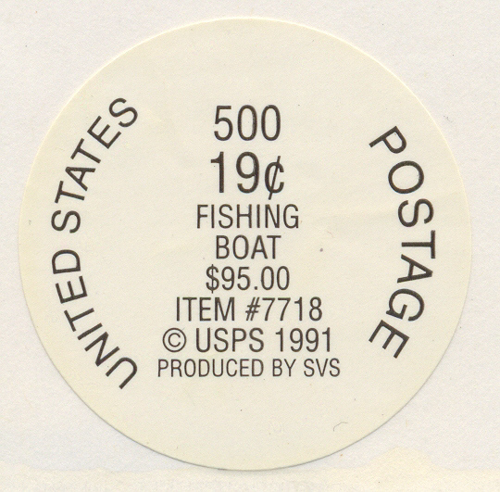
USPS item # information appears on the label as a line of text.

Bar Code Labels – Type C
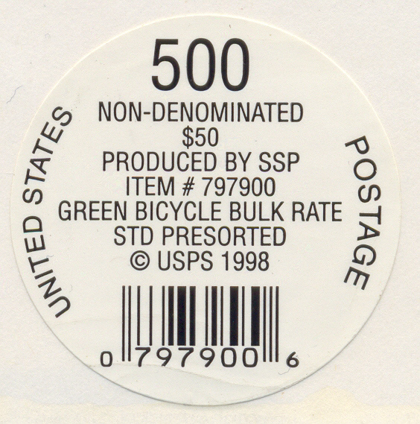
USPS item # information is provided in bar code form as well as an item line of text.

Bubble Pack Panel – Type B

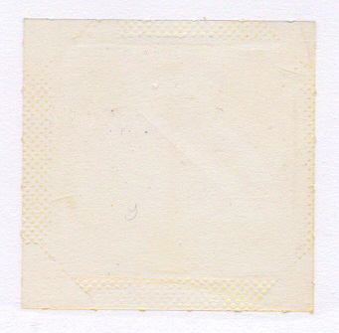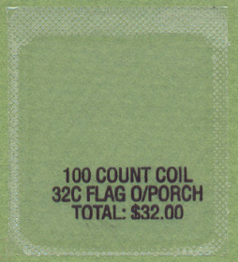
The plastic film cover of plastic bubble packs; when 100-roll bubble packs first appeared, their top panels were unprinted. A label message, if present, was embossed on the bottom of the bubble pack. Later, top panels were printed. All recent printed bubble pack panels have included USPS item # information in bar code form.

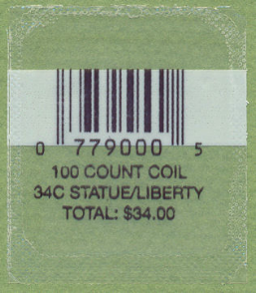

Wrapper Tape – Type T
Printed paper tapes used to hold the lead end of a coil roll in place.
Early 100-roll printed wrapper tapes lack USPS item # bar codes. Recent printed tape wrappers have all included USPS item # information in bar code form as well as a printed image of the stamp.

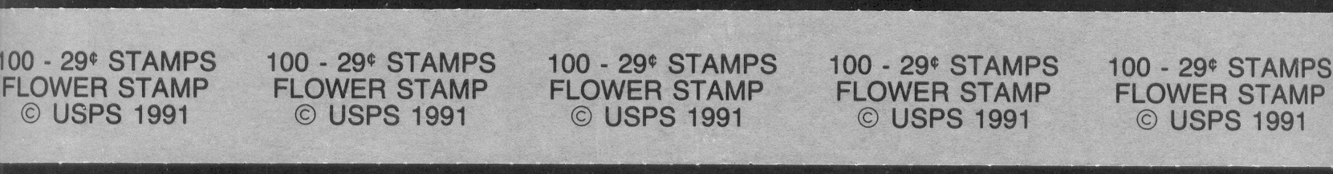

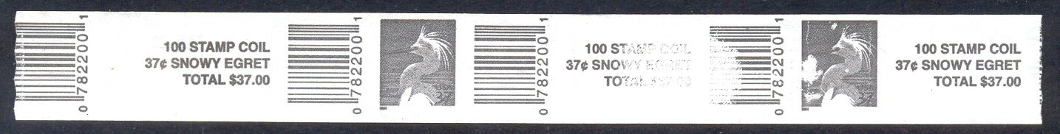

II - Label Type Measurements - UE, C, DT and IL*

UE

UE is measured from the outermost point of “U” in “UNITED” to the outermost point of “E” in “POSYAGE”.

C

C is the length of the © date text line.

DT

DT is the length measured from the outermost corner of “D” in “UNITED “ to the outermost edge of the crossbar in the “T” in “POSTAGE”.

IL

IL is the length of the item # text line.

* Measurements are made in millimeters to the nearest half-millimeter.

III - Label Stock & Paper Types

The label stock component of the LIC identifies the material on which the label message is printed. Paper was the first label stock used for individual PNC labels and continues to be the most prevalent label stock used today. However, following advances in coil packaging and printing technology cardboard and plastic label stock have also been employed.

Originally, all individual PNC labels performed a dual function with respect to the coil roll products to which they were affixed. The label not only identified the contents of the coil package but also, with an adhesive coating on its backside, the label functioned as the “tape” that held in place the protective cellophane wrap that enclosed the coil. The size and disk shape of these labels approximated the size and shape of the rolls they labeled. Today, for the larger coils, 500 and up, the use of plastic shrink-wrap to package these rolls has largely obviated the tape function.

On most 10 K rolls and a few 3K rolls, where the size of the roll requires additional packaging support, cardboard disks are added, usually on both the top and bottom of the roll, before the shrink-wrap is applied. On the first 10K rolls, all BEP products, where this technique was applied, a traditional paper disk label was affixed to the cardboard disk. Later BEP products retained the cardboard disks for support but affixed the paper label to the outside of the plastic wrap. Today, some of the private coil contractors have dispensed with paper labels for these large rolls, printing the label message directly on the cardboard disk.

The use of plastic as a label stock has thus far been restricted to 100-roll bubble pack products. The first bubble pack products were unprinted. These early bubble packs usually carried a label message that was embossed on the bottom of the bubble pack. Later developments enabled print to be applied to the plastic film that was used to cover and seal these bubble packs. Paper wrapper tape that was used to hold the lead ends of these coils in place and prevent unraveling was unprinted. In recent years a number of 100-roll coil products have been secured with wrapper tapes printed with a label message. For these coils the printed wrapper tape functions as the label. Where these rolls are enclosed in a plastic bubble pack, the bubble pack top panel is usually unprinted.

As indicated above, the label stock employed for the first individual PNC coil labels was paper. Several different kinds of paper were used. The individual characteristics of these papers gave rise to the Paper Type, or LIC Lp designations that follow.

Type 1 – White, uncoated paper with a thick waxy coating of heat-sensitive adhesive resin. Label paper is low bright (LB) under LWUV.

Type 2 – White to cream coated paper with glossy backing coated with pressure-sensitive adhesive. Label paper is “dead” (D) under LWUV.

Type 3 – White paper; no backing coated with pressure-sensitive adhesive. The lack of backing allows the adhesive to migrate into the paper. Label paper is high bright (HB) under LWUV.

Type 4 – White, almost translucent, coated paper; thin colorless matte backing coated with pressure-sensitive adhesive. Label Paper is low bright (LB) to medium bright (MB) under LWUV.

Type 4a – Similar to Type 4 paper but thicker and lacking any surface gloss. Label paper is low bright under LWUV

In the years that followed other kinds of paper label stock were used for both BEP and various private contractor produced coil product labels. While these newer papers have not been given type designations, their fluorescence and other significant characteristics are noted in LIC information for these labels. Cardboard label stock is not assigned a type number but the color, shape and dimensions of cardboard labels are noted. Similarly, plastic and the paper stock used for printed wrapper tapes have not been given type designations but the dimensions and other significant characteristics of labels printed on these materials are noted in the LIC information entries as well.

IV - Fonts for the 3 in 3000

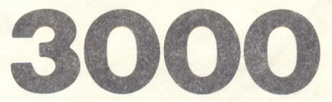
Blunt Font 3 (B) - serif-less center bar

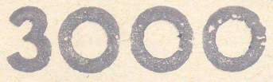
Point Font 3 (P) - sharply pointed center bar

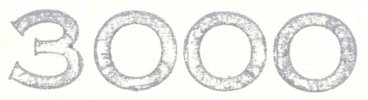
Celtic Font 3 (C) - serifed center bar

V - Label Sizes

The sizes of the first PNC individual roll paper disk labels usually conformed to the size of the coil roll to which they were affixed. 100-roll product label disks were uniformly 25mm in diameter. 500 and 3,000-roll products originally employed so-called “Jumbo” labels that were 45mm and 98mm respectively. However, beginning with the 20c Flag issue a smaller 38mm label for 500-rolls and a 90mm label for 3,000-rolls began to be used. These slightly smaller labels became standard for subsequent BEP produced coils in these roll sizes. In the LIC Label Type information a “J” precedes the Label Type letter where the larger or “Jumbo” disk was employed. The various private contactors who are today the sole produces of coil stamps have used other sizes of disk labels, both paper and cardboard. Where the size of the coil label may be helpful in distinguishing the label, that information is provided in the LIC.

For a detailed explanation of the original Label Identification Code see Label Mania # 1 (January, 1989). This publication can be accessed through the Reference tab on the PNC3 web site - http://www.pnc3.org/

