Knoll varieties

When a PV die cut is on top of a VP die cut, the transition cut from PV to VP forms a knoll as shown below.
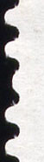
When the die cutting knives are aligned correctly on the image and the coil rolls are cut apart correctly, the knoll shown at the left is cut in half. Sometimes, however, alignment is not what it should be resulting in the knoll varieties illustrated on this page.
⬅ Proper row separation cuts the knoll in half

Note in the illustrations below a shallow valley is always opposite the knoll. Knoll varieties are always identified on the left edge of the stamp.

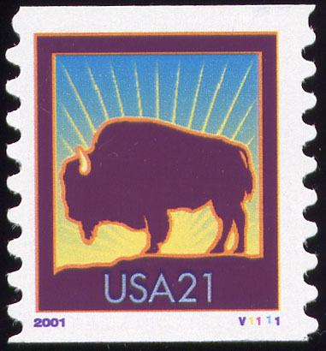
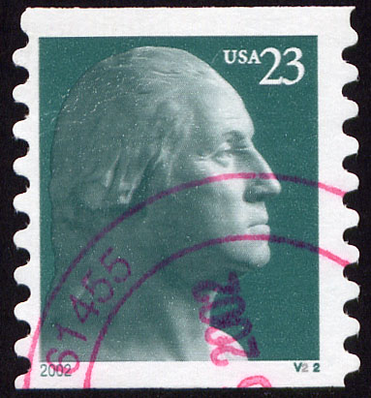
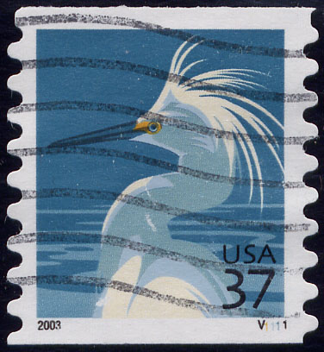

23c Washington
Knoll Top
2002-6.252
Image from Andy Jakes

37c Snowy Egret
Knoll Top
2003-8.252
21c Bison
Knoll Top
2001-2.252

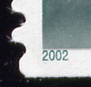
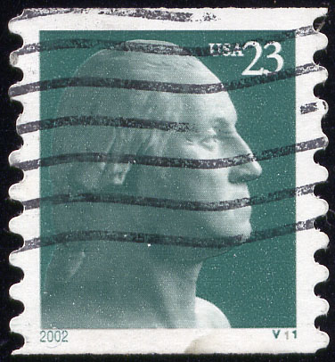
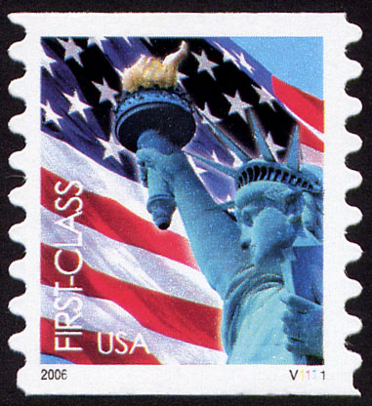

23c Washington
Knoll Bottom close up
2003-6.253
(39c) Liberty/Flag
Knoll Bottom
2005-6.253

Embedded Knoll
2002-6.251
Image from Charles McMullen

Shallow Valley varieties

When a VP die cut is on top of a PV die cut, the transition cut from VP to PV forms a shallow valley shown below.

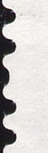
When the die cutting knives are aligned correctly on the image and the coil rolls are cut apart correctly, the shallow valley shown at the left is cut in half. Sometimes, however, alignment is not what it should be resulting in the shallow valley varieties illustrated on this page.

⬅ Proper row separation cuts the shallow valley in half

Shallow Valley is not found on the Snowy Egret (2003-8) because it is believed that only the top row of the web has a PV.

Note in the illustrations below, a knoll is always opposite a shallow valley. Shallow valley varieties are always identified on the left edge.

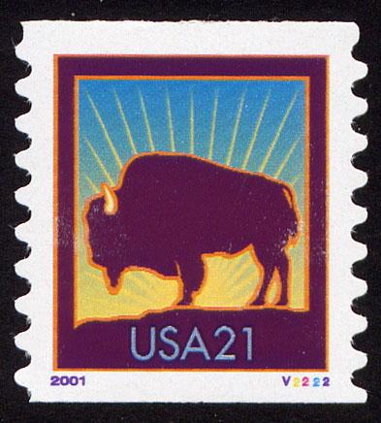
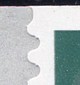
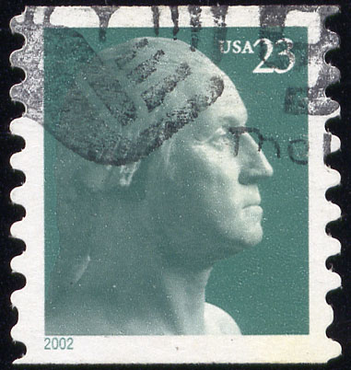

23c Washington
Shallow Valley Top
2002-6.242
23c Washington
Embedded
Shallow Valley
2002-6.241
21c Bison
Shallow Valley Top
2001-2.242

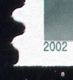

23c Washington
Shallow Valley Bottom
2002-6.243

