Thimble varieties

When the last row of a VP die cut stack is cut too low, a Thimble bottom die cut is formed. If another VP row had been underneath it, a bell bottom would have resulted. A thimble top is formed, when the VP on the top row is cut high. If another VP row had been on top, a bell top would have resulted.

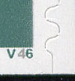

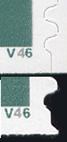

23c Washington Thimble Bottom
2002-6.263

On the right is a comparison image of plate V46 with the thimble on top and the bell on the bottom.

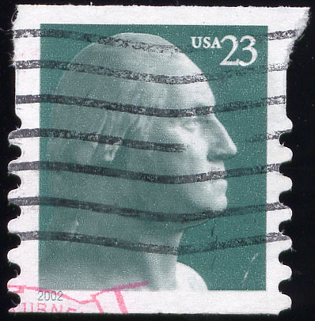
It takes a bit of imagination to see the upside down thimble in the shifted die cut example to the left. This should have been a VP on the top row. The small inset below may make the upside down thimble more discernible.

