Seacoast P2222 Varieties
PNC ID 2003-5
By Frank Covey




P2222 Serpentine die cut 4 sides
P2222 Serpentine die cut 2 sides
Deep Valley Variety




P2222 Serpentine die cut 2 sides
Shallow valley Thick date
Image courtesy of Jeff Fizbein

P2222 Serpentine die cut 2 sides
Deep valley Thin date
Image courtesy of Jeff Fizbein


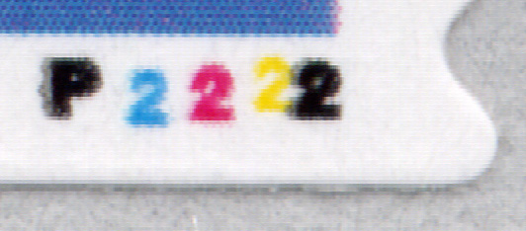

P2222 Black Ghost

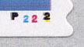

P2222 Tagged Error
P2222 Black Ghost
Two over Two Variety



P2222 Serpentine die cut 4 sides
Backing paper not removed



Deep
Valley
From P2222
(Haake)
Shallow
Valley
From P2222
(Covey)

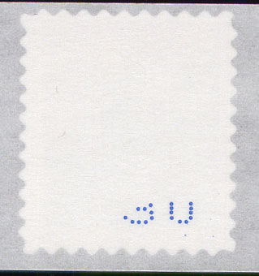
Paritial 2-digit
Back Number
From P2222
Seacoast

